Internship Database

Names: Ragy Costa de jesus

Kaden Carr

Ben Heins

Instructor: Paul Allen

Course: Intro to Data Engineering

Date: May 3, 2022

# Design and Features

This internship database is a product that will allow a student at Florida Gulf Coast University who is looking for an internship to search through this database and find themselves an internship that fits their future career. The database shall store an internship that has been processed and approved by the internship department of the Whitaker College of Engineering. The software will contain vital information to determine if the student is fit for the respective internship. This software will utilize PyCharm to create table relations and tables and allow for an easy transition when designing a UI.

The database will contain the following features:

* A search bar that allows the student to search for an internship
* Allows for keywords searches of internship ID’s
* Allow to insert new internships into the database

This product will utilize a search bar that allows students to search up keywords and company names to help themselves find an internship that matches their needs. The UI will also be simple and easy to use.

# Analysis and Development Techniques Applied

We first brainstorm about what attributes we need to create an internship database. After analyzing, we came up with the following tables: Person, student, major, company, and internship tables; after finding the entities, we proceeded to find the characteristics of each of the entities to make the attributes. We ask the following question to find the characteristics of each entity: What makes [entity] an [entity]? What are the characteristics of a [entity]? What is a [entity]? As a result, we find characteristics such as names, addresses, and descriptions of the entities. The project's next phase is to create a connection between the entities. We did this by creating relationship entities and connecting a relationship between the entities. The relationship entities are takes, offers, and hires. Each name describes how the two entities are related. To create a connection, we need to identify the primary keys. We first had to find the super keys and then-candidate keys to find the primary.

|  |  |  |  |  |
| --- | --- | --- | --- | --- |
| **Table** | **Keys Type** | **Super Keys** | **Candidate Keys** | **Primary Key** |
| Person | | personID, phoneNumber, email | personID,  (phoneNumber, email),  (personID, email),  (personID, phoneNumber) | personID |
| Student | | studentID | studentID | studentID |
| Major | | majorID,  majorName | majorID,  (majorID, majorName), | majorID |
| Company | | companyID,  companyName,  LinkToWeb | companyID,  (companyID, companName),  (companyID, LinkToWeb),  (companyID _ID, LinkToWeb) | companyID |
| Internship | | internshipID | internshipID | internshipID |

After creating the connection, we completed the ER model to have an overall view of how the system looks and correlates with each other. In addition, we made assumptions to find the cardinalities of the related entities. The following assumptions were made:

# Assumptions

* A student can have many majors
* An internship cannot exist without a company that offers it
* A Company can hire one or many persons for an internship
* A student can only take one internship and an internship can have only one student taking it
* A company can offer many internships, but an internship is only be offered by one company

With the help of the above-mentioned assumptions, we finish up the ER-model and ultimately finish up the Internship Schema. Below are the ER-model and Schema of Internship.

# Application Architecture

The application architecture that we use are pySimpleGUI and SQLite3 to connect the database with the UI. The database will connect to the SQLite3 and illustrate the application with pySimpleGUI.

Internship database ER- models

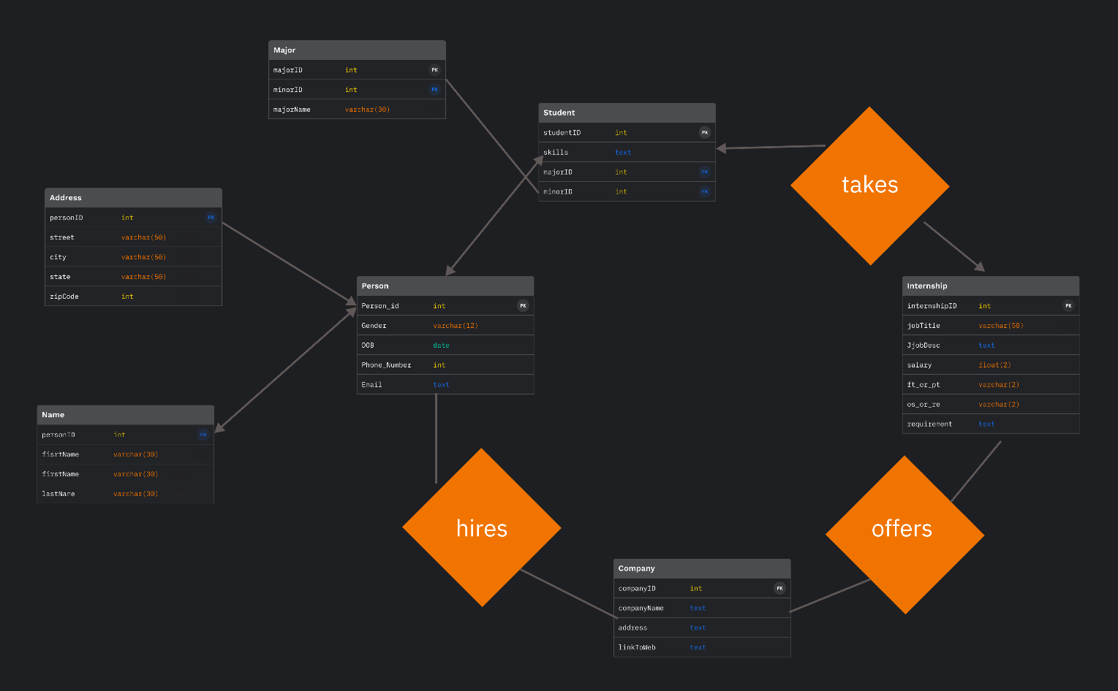Linke to ER-model: <https://www.figma.com/file/K8hSP4Z5AjmuPJiUKtS2cR/Internship-ERD?node-id=18%3A899>

Internship Schema

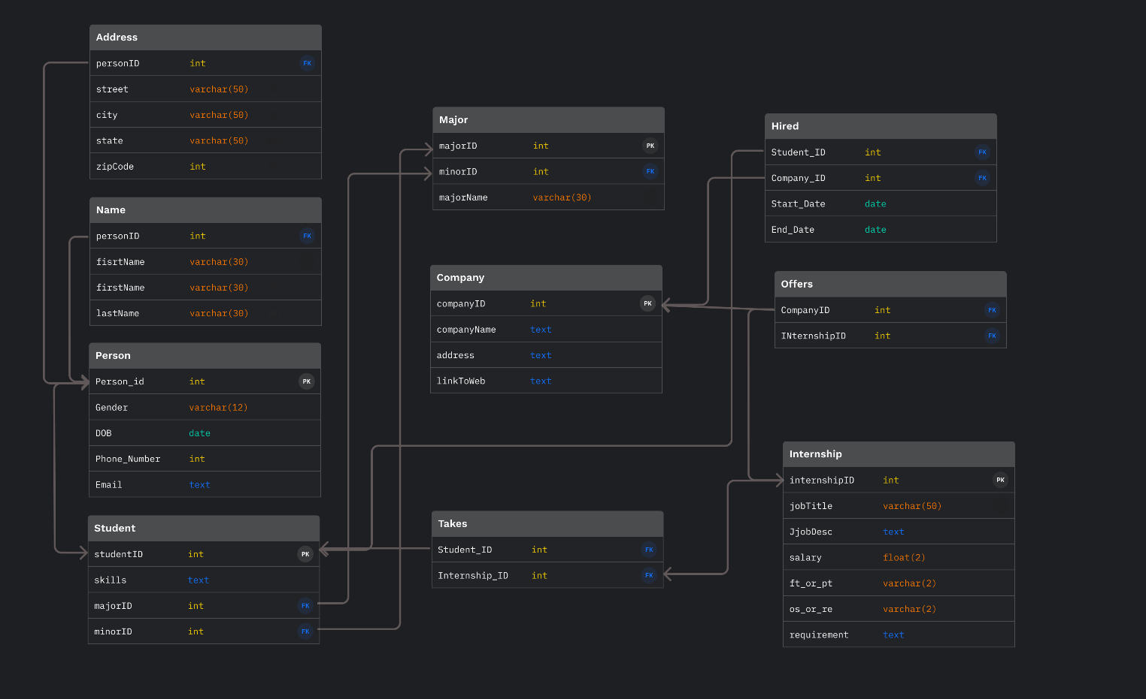Linke to schema: <https://www.figma.com/file/K8hSP4Z5AjmuPJiUKtS2cR/Internship-ERD?node-id=18%3A899>